PIZZALOKA SQL QUERIES
KPIs
- TOTAL REVENUE
-- KPI TOTAL_REVENUE
SELECT SUM(total_price) AS total_revenue
FROM pizzaloka_sales

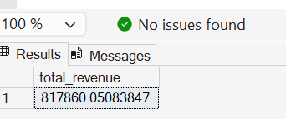

- AVERAGE ORDER VALUE
-- KPI average_order_value
SELECT SUM(total_price) / COUNT(DISTINCT order_id) AS average_order_value
FROM pizzaloka_sales

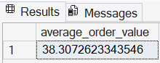

- TOTAL PIZZAS SOLD
-- KPI total_pizzas_sold
SELECT SUM(quantity) AS total_pizzas_sold
FROM pizzaloka_sales

- TOTAL ORDERS PLACED
-- KPI total_orders_placed
SELECT COUNT(DISTINCT order_id) AS total_orders_placed
FROM pizzaloka_sales

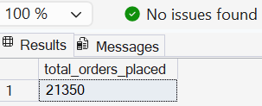
- AVERAGE PIZZAS PER ORDER
-- KPI average_pizzas_per_order
SELECT CAST (CAST
(SUM(quantity) AS DECIMAL(10,2)) / CAST (COUNT(DISTINCT order_id) AS DECIMAL(10,2)) AS DECIMAL (10,2))
AS average_pizzas_per_order
FROM pizzaloka_sales

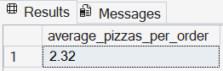

Chart Requirements

- TOTAL ORDERS PER DAY
-- CHART daily trend
SELECT DATENAME(WEEKDAY, order_date) AS order_day , COUNT(DISTINCT order_id) AS total_order
from pizzaloka_sales
GROUP BY DATENAME(WEEKDAY, order_date)
ORDER BY COUNT(DISTINCT order_id) ASC

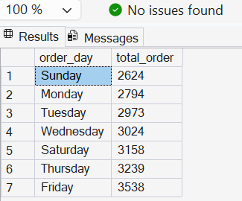

- HOURLY TREND FOR TOTAL ORDERS
-- CHART hourly trend
SELECT DATEPART (HOUR, order_time) AS order_hour , COUNT(DISTINCT order_id) AS total_order
from pizzaloka_sales
GROUP BY DATEPART (HOUR, order_time)
ORDER BY DATEPART (HOUR, order_time)

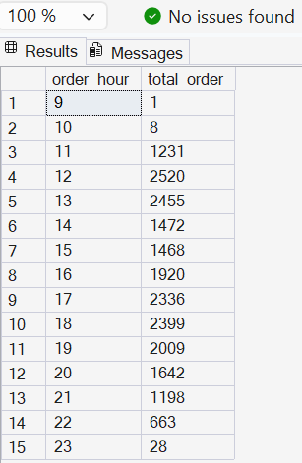

- AVERAGE PIZZAS PER ORDER
-- CHART percentage of sales by pizza category
SELECT pizza_category , SUM (total_price) * 100 / (SELECT SUM (total_price) FROM pizzaloka_sales) AS percentage
FROM pizzaloka_sales
GROUP BY pizza_category

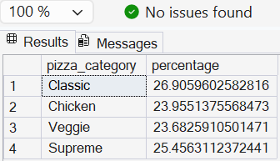

- QUANTITY BY PIZZA SIZE
-- CHART quantity sold by pizza size
SELECT SUM (quantity) AS total_quantity_sold , pizza_size
FROM pizzaloka_sales
GROUP BY pizza_size
ORDER BY SUM (quantity) DESC

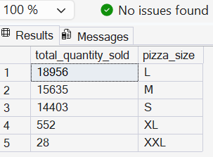

- TOTAL SALES BY PIZZA CATEGORY
-- total pizzas sold by pizza category
SELECT pizza_category , SUM(quantity) AS total_price
FROM pizzaloka_sales
GROUP BY pizza_category

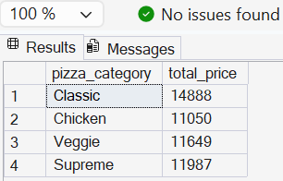

- TOP 5 BEST SELLERS BY PIZZA NAME
-- top 5 best sellers by pizza name
SELECT TOP 5
pizza_name , SUM(quantity) AS total_quantity
FROM pizzaloka_sales
GROUP BY pizza_name
ORDER BY SUM(quantity) DESC

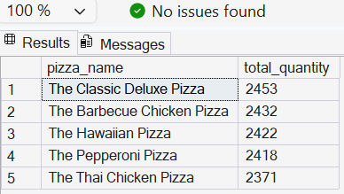

- BOTTOM 5 WORST SELLERS BY PIZZA NAME
-- bottom 5 worst sellers by pizzas name
SELECT TOP 5
pizza_name , SUM(quantity) AS total_quantity
FROM pizzaloka_sales
GROUP BY pizza_name
ORDER BY SUM(quantity) ASC



